22.54: a) The electric field of the slab must be zero by symmetry. There is no preferred direction in the -z plane, so the electric field can only point in the -direction. But at the origin in the -direction, neither the positive nor negative directions should be singled out as special, and so the field must be zero.
b) Use a Gaussian surface that has one face of area A on in the -z plane at 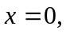 and the other face at a general value Then:
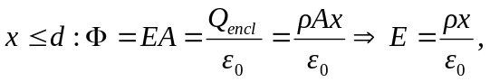
with direction given by 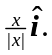
Note that  is zero at 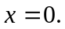
Now outside the slab, the enclosed charge is constant with
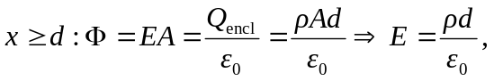
again with direction given by

